Lincoln UTC Remote Learning Statement
COVID19

Lincoln UTC is firmly committed to providing an excellent level of education to all learners and will continue do so in the event of a forced school closure, through a process of remote (online) learning.
In the event of a forced school closure all students that can be looked after, or those who can work independently and confidently at home, should remain at home. A limited number of places will be available within the UTC for those students who are vulnerable, unable to cope with remote learning, or who cannot be looked after by an appropriate adult.
Online learning will be provided to groups of students that form a bubble, should they be instructed to isolate at home due to a positive COVID19 case within that bubble.
Individuals who are isolating due to a family member testing positive for COVID19, or similar, will be supported with tasks to complete in their absence. In this instance online ‘live lessons’ will not be available, however, online work set via email will be arranged.
The online learning timetables for all students can be seen below.
Year 10 and year 11 lessons have been organised within the timetable so that every 50 minute lesson is followed by an ‘independent extension’ task. These independent tasks should take no longer than the 30 minutes allocated within the timetable. There are regular breaks throughout the day for students.

YEAR 10 STUDENT TIMETABLE:
 | Start time | 9.00 | 9.50 | 10.40 | 11.30 | 1.00 | 1.50 | 2.40 | 3.30
 | End time | 9.50 | 10.20 | 11.30 | 12.00 | 1.50 | 2.20 | 3.30 | 4.00
 |  | 1 | 2 | 3 | 4 | 5 | 6 | 7 | 8
Y10 | Monday | Science | Follow up activity | English | Follow up activity | Engineering | Follow up activity | Well Being
 | Tuesday | Options | Follow up activity | Maths | Follow up activity | English | Follow up activity | Science | Follow up activity
 | Wednesday | Maths | Follow up activity | Science | Follow up activity | Engineering | Follow up activity | Science | Follow up activity
 | Thursday | Options | Follow up activity | Engineering | Follow up activity | English | Follow up activity | Maths | Follow up activity
 | Friday | Science | Follow up activity | English | Follow up activity | Engineering | Follow up activity | Science | Follow up activity

YEAR 11 STUDENT TIMETABLE:
 | Start time | 9.00 | 9.50 | 10.40 | 11.30 | 1.00 | 1.50 | 2.40 | 3.30
 | End time | 9.50 | 10.20 | 11.30 | 12.00 | 1.50 | 2.20 | 3.30 | 4.00
 |  | 1 | 2 | 3 | 4 | 5 | 6 | 7 | 8
Y11 | Monday | Engineering | Follow up activity | Science | Follow up activity | English | Follow up activity | Well Being
 | Tuesday | Maths | Follow up activity | Science | Follow up activity | Options | Follow up activity | English | Follow up activity
 | Wednesday | Science | Follow up activity | Maths | Follow up activity | Science | Follow up activity | English | Follow up activity
 | Thursday | Engineering | Follow up activity | Maths | Follow up activity | Science | Follow up activity | Engineering | Follow up activity
 | Friday | English | Follow up activity | Science | Follow up activity | Options | Follow up activity | Engineering | Follow up activity

YEAR 12 STUDENT TIMETABLE:
 | Start time | 9.00 | 9.50 | 10.40 | 11.30 | 1.00 | 1.50 | 2.40 | 3.30
 | End time | 9.50 | 10.40 | 11.30 | 12.20 | 1.50 | 2.40 | 3.30 | 4.20
 |  | 1 | 2 | 3 | 4 | 5 | 6 | 7 | 8
Y12 | Monday |  | Engineering Triple | Fu Maths | Maths | Biology | Engineering Triple | Well Being
 | Tuesday | Engineering Single | Business | Engineering Triple | Biology | Fu Maths | Computer Science | Physics | Engineering Triple
 | Wednesday | Engineering Triple | Maths | English | Chemistry | Engineering Single | Business | Computer Science | Engineering Triple
 | Thursday | Biology | English | Chemistry | Engineering Triple | Fu Maths | Business | Physics | Engineering Single
 | Friday | Maths | Engineering Triple | Computer Science |  | Physics | Chemistry | English

YEAR 13 STUDENT TIMETABLE:
 | Start time | 9.00 | 9.50 | 10.40 | 11.30 | 1.00 | 1.50 | 2.40 | 3.30
 | End time | 9.50 | 10.40 | 11.30 | 12.20 | 1.50 | 2.40 | 3.30 | 4.20
 |  | 1 | 2 | 3 | 4 | 5 | 6 | 7 | 8
Y13 | Monday | Engineering Triple | English | Physics | Biology | Fu Maths | Engineering Single | Well Being
 | Tuesday | Chemistry | Maths | Business | Computer Science | Engineering Single | Engineering Triple | Fu Maths | English
 | Wednesday | Maths | Engineering Triple | Biology | Business | English | Engineering Triple | Fu Maths | Computer Science
 | Thursday | Chemistry | Biology | Physics | Business | Engineering Triple |  | Engineering Single | Engineering Triple
 | Friday | Computer Science | Maths |  | Engineering Triple |  | Physics | Chemistry

All instructions related to our online learning platforms will be communicated to students via their Lincoln UTC student email, as well as to parents via the most recent email address that we hold on our MIS.
LINCOLN UTC STUDENT EMAILS:

All students at Lincoln UTC have their own email address.

If students have difficulty because they have not used their Lincoln UTC email for some time, please email ONE of the following contacts who will confirm the email address and username to be used.

SIXTH FORM: rlittle@lincolnutc.co.uk

KEY STAGE 4: ssteward@lincolnutc.co.uk

In a forced closure the UTC reception will not be staffed. If you have any general questions please contact us on:
enquiries@lincolnutc.co.uk
If you have any specific safeguarding concerns during this time of closure please contact us on:
safeguarding@lincolnutc.co.uk

GOOGLE CLASSROOM:

The primary online learning platform the UTC will use is Google Classroom.

All students must access google classroom via their Lincoln UTC email.
NOTE: Personal email accounts will not work!

The passwords / access codes will be communicated to all students and their parents in advance of any forced closures.

Most lessons have three or more staff that are present on the Google Classroom so that all student conduct and questions are monitored. This ensures that students are using the classroom appropriately as well as to ensure that the students’ questions are addressed in a timely manner.
The majority of broadcast lessons are recorded and available for students to re-watch and re-view. For many students this will be something that is very helpful, particularly if students are finding the remote and independent learning difficult.
Where lessons are not recorded, teaching staff remain ‘online’ in the Google Classroom once the timetabled lesson has come to an end. Students will be encouraged to remain in that lesson should they need to ask questions or clarify any particular aspects of learning.
SUBMISSION OF WORK
All students will be required to submit work via Google Classroom in line with the communicated deadlines. Work will be marked by subject specialists and feedback to students will be provided.

ATTENDANCE / CONDUCT WITHIN LESSONS
Attendance is monitored by one of the members of staff present within Google Classrooms. Staff will take at least two registers during the course of the lesson to ensure attendance is recorded accurately. Parents / carers will be informed if there are attendance concerns.
EXPECTATIONS OF OUR STUDENTS
The expectation of students is simple. Students must:
- Attend all online lessons
- Follow the ‘End-User Agreement’ instructions (see below)
- Complete work that is set in line with the communicated deadline
Students who fail to follow the End-User Agreement will be removed from online learning for that session. Parents of students who repeatedly fail to follow the End-User Agreement will be contacted directly resulting in the possible removal of online learning. Removal of online learning will be recorded in SIMS as an exclusion. In this case written work will be supplied for the student to complete.
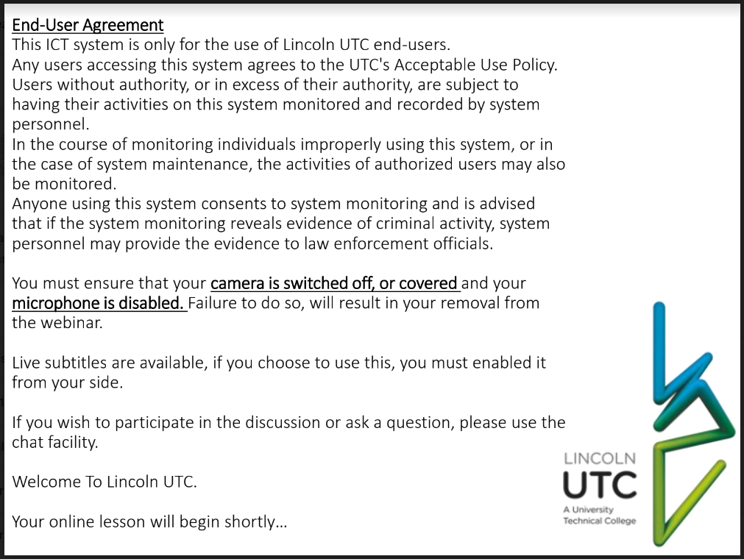
ADVICE FOR STUDENTS AND PARENTS:
A ‘Top Ten’ guide for students and parents can be found at the bottom of this statement.
NOTE: Students should ignore point 7 on the top ten guidance as they do not need to be present for lessons in uniform. Indeed students should not be entering Google Classrooms with their camera working.

